**Instructions for AP Invoice Stamp**

Save the below template in the location shown below.



*When you open the stamp, scroll all the way down the page to see the stamp.

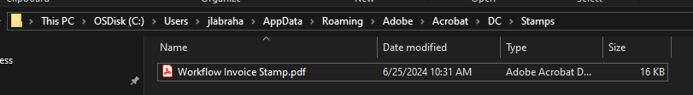

**Saving the template:**

OSDisk [C]

Users

jlabraha->will be your user name

AppData

Roaming

Adobe

Acrobat

DC

Stamps

Update doc name to Workflow Invoice Stamp

Select Save

**Adding Stamp into Adobe**

Open Adobe Acrobat

Select-> See all tools

Select the Stamp icon

Select Custom Stamps

Select Create

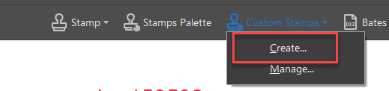

Select Browse – Go find stamp template you just saved above.

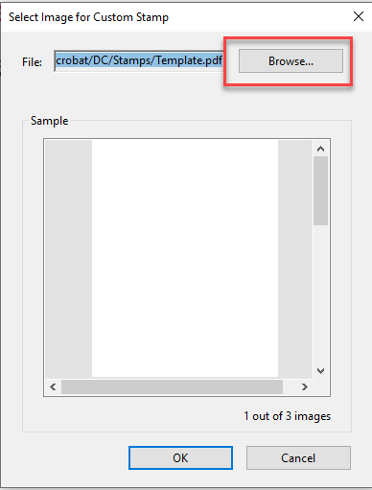

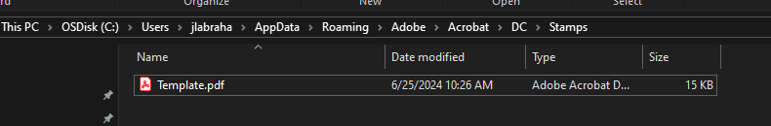

Select Ok

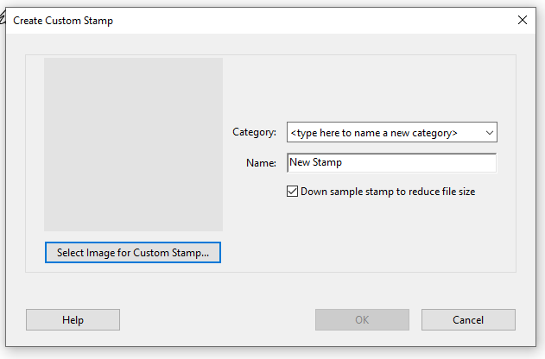

Enter new category -> Invoice Processing

Enter new Name ->Workflow Invoice Stamp

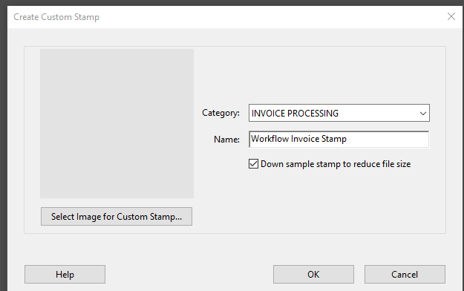

Select Ok

**Adding Stamp to invoices**

Go to your scanned invoices folder and open an invoice.

Open Stamp from tools tab

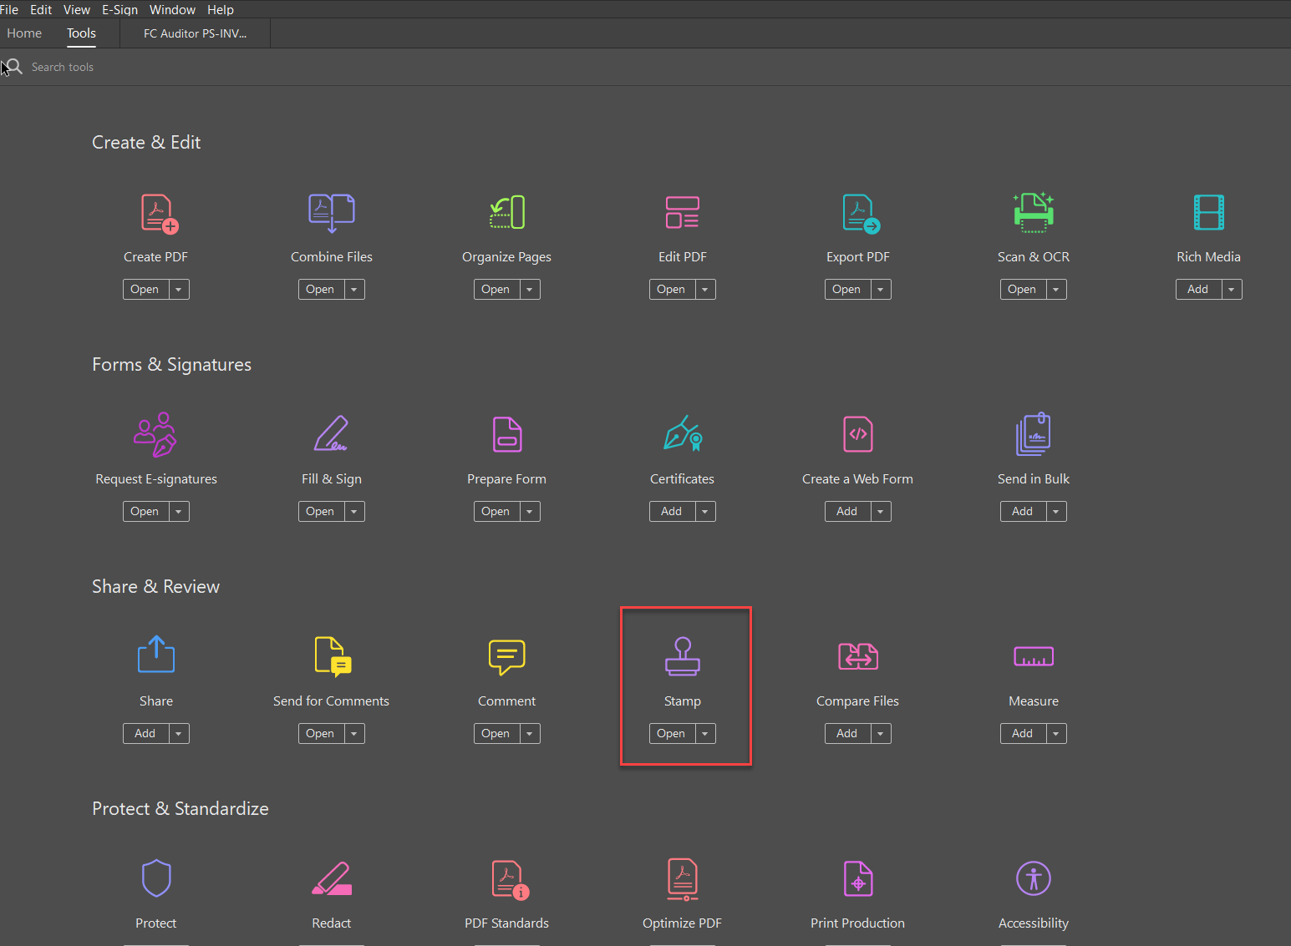

Using the drop-down arrow on the Stamp Icon select Invoice Processing -then select >stamp image

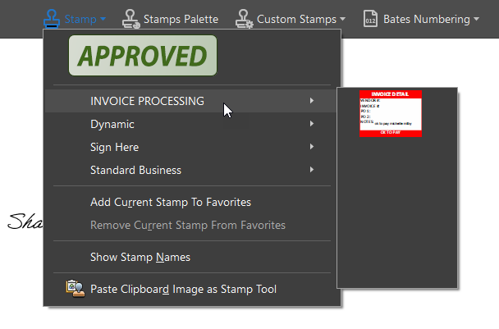

Your stamp will now appear in the invoice

Left click to open the invoice details box

Fill in the invoice details

Hit ok for next item until done

Adjust size and position on invoice as needed

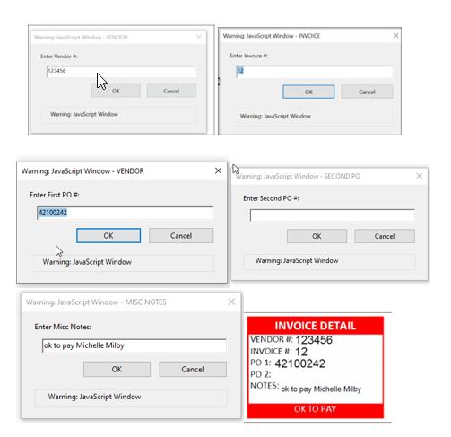

Save the Invoice 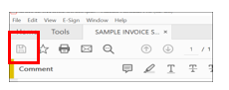

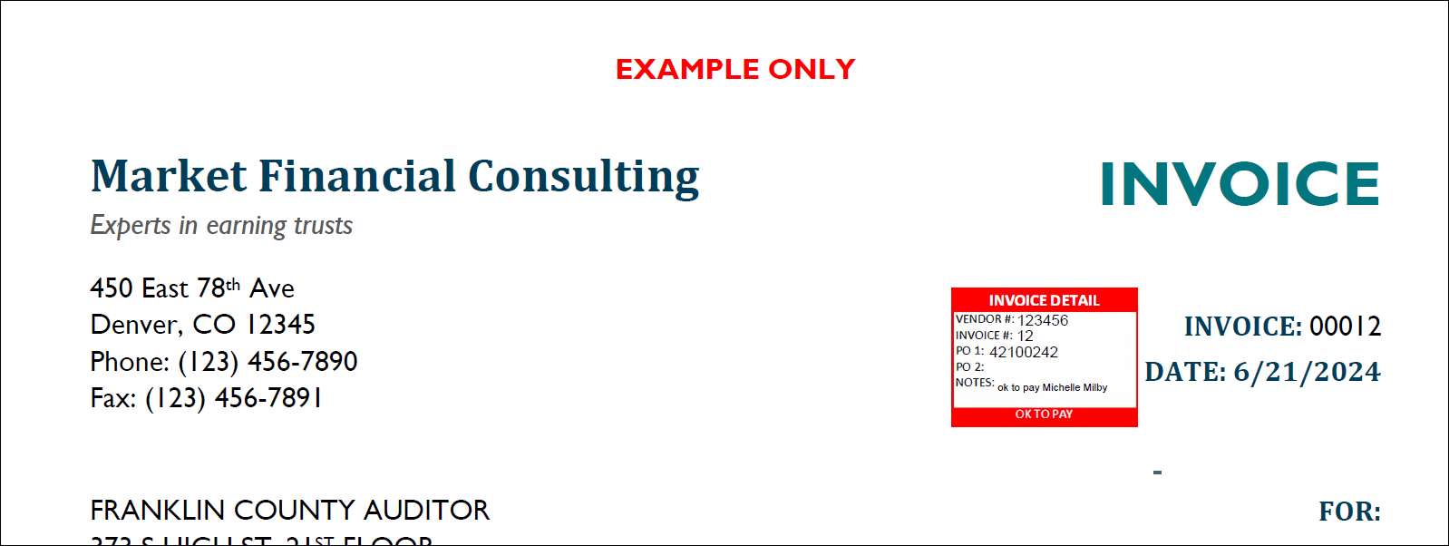

Go to next invoice and repeat process